Cyber Security and Privacy

-Harsh Suryavanshi, Bharati Vidyapeeth College of Engineering

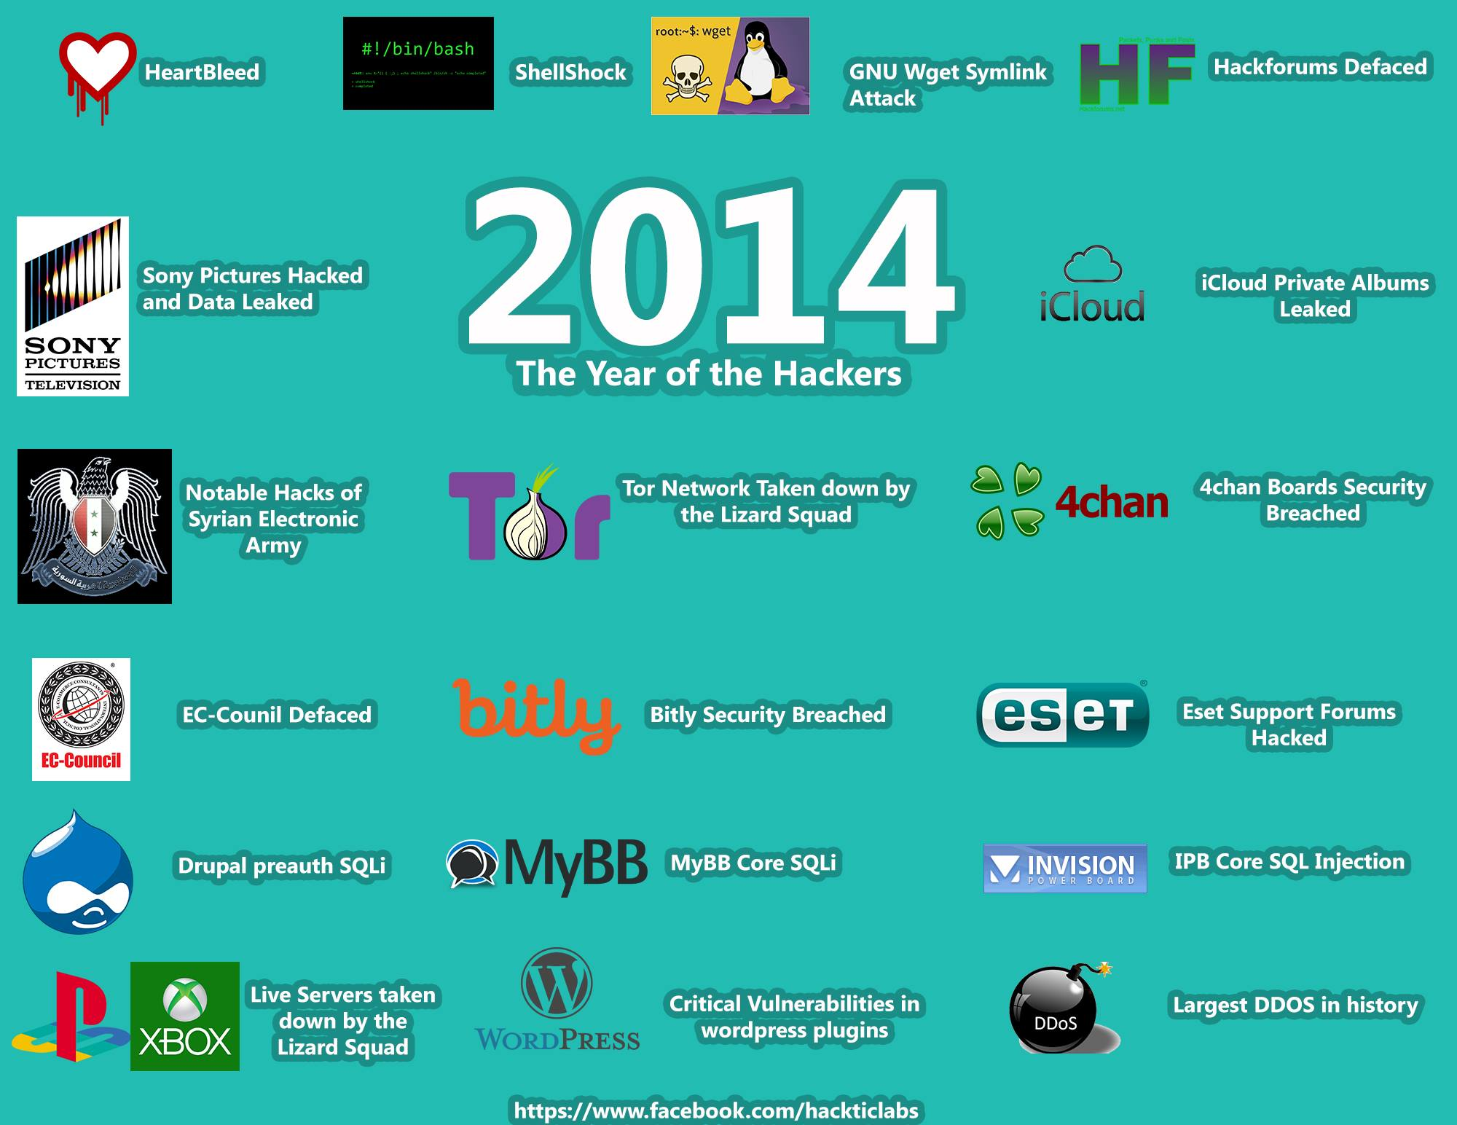

Cyber Security is a major concern for today’s cyber world. When you are online, it is almost impossible to trust anyone. Whether you are a Developer, a normal user or running a business online, you become the target of cyber criminals, covert government agencies and many other spying programs. The NSA Prism spying program is a good example where National Security Agency, USA was found spying on its own citizens, companies and many other people around the world, using various monitoring techniques and phone tapping methods. Seizing of many TOR Darknet websites in Europe is another example where anybody can imagine what level of anonymity he has.

Some of recent examples of Cyber-attacks and data breaches are 7 million Gmail password leaks, Dropbox password leaks, ITunes Hack, Sony media hack and Hijacking of Google Indonesia Domain. There are a number of attacks that are taking place even as you’re reading this article. New bugs, zero day Vulnerabilities and zero day exploits are being found every day, examples of some such serious vulnerabilities are Shellshock, DHCPShock and Heartbleed.

If we talk about a normal user, he is being tracked by many tech giants like Facebook, Google with cookies and sessions. A hacker in some corner of the world may have turned your system into a zombie without your knowledge through his bots, malwares and rootkits, bypassing firewalls and antivirus protections.

Now where is the problem? What can we do? We do a lot of bank transactions, shopping with the same system, so what about our secrets and privacy? The best thing one can do is being aware about the threats, using updated software and VPNs with no logs for anonymity to create awareness among people and serious users. There are many Human Right Activists who are fighting for justice in the cyber world after NSA program. The OWASP (OPEN WEB APPLICATION SECURITY PROJECT) have been helping developers and pen testers by releasing many security Guidelines and resources for years. All hackers are not evil, instead they are the immunity system of the Internet which help us find loopholes and thereby changing our methodologies, forcing us to adopt new technology. Being aware about all such threats even the Indian Government also launched CERT-INDIA (Computer Emergency Response Team – INDIA) and NSD (National Security Database). So there are challenges and threats in cyber world but there is also hope and people to tackle those challenges.